

The process of dividing a market into distinct groups or segments based on similar characteristics, needs, or behaviors of the target customers is known as **“Market Segmentation”**

Market Segmentation Analysis

**TEAM MEMBERS:**

[Abdul Jaweed](https://www.linkedin.com/in/abdul-jaweed-datascientist/)

[Ashvath Suresh Babu Piriya](https://www.linkedin.com/in/ashvath-suresh)

Sai Satwik Yarapothini

Shaleen Mishra

Yashaswini M

**TASK-2**

**What is Market Segmentation?**

Market segmentation is the practice of breaking down a large target market into more narrowly defined subgroups or segments based on shared traits or requirements. Market segmentation aims to recognise and better serve several client groups’ unique tastes, tendencies, and needs within a broader market.

**What is Market Segmentation Analysis?**

Examining and assessing the various market segments within a more significant market goal is known as market segmentation. To understand each segment’s distinctive qualities, actions, hobbies, and calls, information about each segment must be gathered. Using market segmentation analysis, businesses can make sound choices and create marketing plans suited to each category’s distinctive wants.

**STEPS INVOLVED IN MARKET SEGMENTATION ANALYSIS ARE:**

**Step 1: Deciding (not) to Segment**

***1.1 Implications of Committing to Market Segmentation***

Market segmentation is a marketing strategy that requires a long-term commitment and substantial organisational investments.

Before pursuing market segmentation, it is essential to understand its implications. Committing to market segmentation involves research, surveys, package design, and advertising costs. It may require product development, pricing, distribution channels, and communication methods changes.

The organisational structure may need to be adjusted to focus on market segments rather than products. The decision to pursue market segmentation should be made at the highest executive level and communicated throughout the organisation.

Implementing market segmentation successfully requires overcoming barriers such as resistance to change, lack of market orientation, and inadequate planning. Senior management is crucial in providing leadership, involvement, and resources. Organisations should foster a market-oriented culture, promote effective communication, provide training, and allocate sufficient financial resources.

Understanding the implications and addressing potential barriers will help organisations determine if market segmentation is a suitable long-term strategy for them.

***1.2 Implementation Barriers***

The implementation of a market segmentation strategy can face barriers that can impede its success. These barriers can be categorised into different groups.

The first group of barriers relates to senior management. Lack of leadership, commitment, and involvement in the market segmentation process by senior leadership can undermine the success of market segmentation.

The second group of barriers relates to organisational culture. Factors such as a lack of market or consumer orientation, resistance to change, lack of creative thinking, poor communication, and a lack of sharing information and insights across organisational units can prevent the successful implementation of market segmentation. Short-term thinking, unwillingness to make changes, and office politics can also be barriers.

Lack of training and understanding among senior management and the segmentation team can also hinder the implementation of market segmentation. If they do not understand the foundations of market segmentation or the consequences of pursuing such a strategy, the attempt to introduce market segmentation is likely to fail.

Objective restrictions, such as a lack of financial resources or the inability to make necessary structural changes, can hinder the implementation of market segmentation.

Identifying these barriers from the outset of a market segmentation study and proactively addressing them is crucial. If barriers cannot be removed, it may be necessary to consider abandoning the exploration of market segmentation as a potential strategy.

**Step 2: Specifying the Ideal Target Segment**

***2.1 Segment Evaluation Criteria***

The importance of user input in market segmentation analysis and outlines the process of evaluating market segments for target market selection. Here is a summary of the key points:

User Involvement: User input is crucial throughout the market segmentation analysis process and should not be limited to the beginning or end stages. The user, typically an organisation, needs to be actively involved in various stages of the analysis.

Contribution in Step 2: In Step 2, the organisation contributes conceptually by determining two sets of segment evaluation criteria: knock-out criteria and attractiveness criteria. Knock-out criteria are essential and non-negotiable features that segments must possess to be considered for targeting. Attractiveness criteria are used to evaluate the relative attractiveness of the remaining segments.

**Knock-Out Criteria:**  Knock-out criteria are used to determine if market segments qualify for assessment using attractiveness criteria. These criteria include homogeneity, distinctiveness, size, matching the organisation’s strengths, identifiability and reachability.

**Attractiveness Criteria**: Attractiveness criteria are used to evaluate market segments based on their relative attractiveness. Table 4.1 in the passage provides a selection of proposed attractiveness criteria from various sources. These criteria help assess factors such as market potential, growth, profitability, competitiveness, compatibility, and more.

**Structured Process:** It is recommended to follow a structured process for evaluating market segments. One popular approach is using a segment evaluation plot, which maps segment attractiveness against organisational competitiveness. This plot helps visualise and compare different segments to aid in target market selection.

**Step 3: Collecting Data**

Top of Form

In market segmentation, the term “segmentation variable” refers to the variable in empirical data that is used to divide the sample into market segments. In common sense segmentation, the segmentation variable is typically a single characteristic of the consumers, such as gender. This variable is used to split the sample into segments, such as a segment of women and a segment of men. Other personal characteristics in the data, such as age, number of vacations taken, and benefits sought, are called descriptor variables and are used to describe the segments in detail.

In data-driven market segmentation, multiple segmentation variables are used to identify or create market segments. These variables serve as the starting point for segment identification. For example, instead of using gender as the segmentation variable, the benefits sought may be used. The data is sorted based on this set of segmentation variables to reveal segments that share common sought benefits.

The choice of segmentation criteria or variables depends on the nature of the market and the goals of the segmentation. Common segmentation criteria include geographic, socio-demographic, psychographic, and behavioural variables.

**Geographic segmentation** uses the consumer’s location of residence as the segmentation criterion. It is useful for targeting specific geographic regions and tailoring communication messages accordingly. However, it may not capture other relevant characteristics that drive consumer behaviour.

**Socio-demographic segmentation** uses criteria such as age, gender, income, and education to divide consumers into segments. It is useful in industries where these characteristics are directly related to product preferences, such as luxury goods or retirement villages. However, socio-demographics may not fully explain consumer behaviour.

**Psychographic segmentation** focuses on psychological criteria, such as beliefs, interests, preferences, and aspirations. It seeks to understand the underlying reasons for consumer behaviour. Psychographic segmentation often uses multiple variables to capture the complexity of consumer psychology. Travel motives or lifestyle preferences are examples of psychographic segmentation variables.

**Behavioural segmentation** directly looks at consumer behaviour or reported behaviour. It considers factors like prior experience, frequency of purchase, and amount spent. Behavioural segmentation is based on actual behaviour and can provide valuable insights into consumer preferences and purchasing patterns.

The choice of segmentation criteria depends on the specific market and product/service being segmented. It is important to use the simplest approach that effectively captures the relevant characteristics of the target market.

Bottom of Form

Top of Form

Important considerations when using survey data for market segmentation analysis. Here are the key aspects discussed:

**Choice of Variables**: Selecting the appropriate variables is crucial for the quality of the market segmentation solution. All relevant variables should be included while avoiding unnecessary variables that can lead to respondent fatigue and hinder the identification of optimal market segments.

**Response Options**: The response options provided to respondents in surveys determine the scale of the data for analysis. Binary and metric response options are well-suited for segmentation analysis, while ordinal data (e.g., Likert scale) may pose challenges due to the undefined distance between adjacent answer options.

**Response Styles:** Survey data can be affected by response biases and styles, such as acquiescence bias or extreme responding. These biases can impact segmentation results, and it is important to minimise their influence by careful questionnaire design and additional analyses if necessary.

**Sample Size:** Sufficient sample size is essential for accurate segmentation analysis. Insufficient sample size can make it difficult to determine the correct number and nature of market segments. Recommendations vary depending on the segmentation algorithm and the number of segmentation variables, but a sample size of at least 60 times the number of variables is suggested.

**Step 4: Data Exploration**

In Step 4, we explored the collected data to gain valuable insights and uncover patterns that inform the market segmentation. By delving into the data, we aimed to understand our target audience’s characteristics, behaviours, and preferences more deeply, enabling us to develop effective segmentation strategies and targeted marketing initiatives.

*Data Cleaning and Preparation:*

To ensure the data’s quality and usability, we cleaned and prepared it, which involved several essential steps:

1. Removing duplicates, inconsistencies, and errors from the dataset.
2. Handling missing data by imputing or removing incomplete records.
3. Standardising and formatting variables for consistency and ease of analysis.
4. Transforming and encoding variables as necessary for statistical analysis or modelling.

*Descriptive Statistics:*

Descriptive statistics played a vital role in summarising the data and identifying key characteristics of our target market segment. We utilised various descriptive statistics techniques, including:

1. Measures of central tendency such as mean, median, and mode provided insights into variables’ average or typical values.
2. Measures of dispersion, like standard deviation, range, and interquartile range, indicated the variability or spread of data.
3. Frequency distributions in the form of frequency tables or histograms helped us visualise the distribution of values within variables and identify any patterns or anomalies.

*Visualisation Techniques:*

Data visualisation proved a powerful tool for exploring and presenting data visually. It allowed us to understand better the dataset’s relationships, trends, and patterns. We utilised the following visualisation techniques:

1. Bar charts and pie charts represent categorical variables and compare frequencies or proportions.
2. Histograms and box plots to analyse the distribution and spread of continuous variables.
3. Scatter plots display the relationship between two continuous variables, facilitating the identification of correlations or trends.
4. Heatmaps and correlation matrices depict the strength and direction of relationships between multiple variables.

*Data Segmentation and Clustering:*

As part of data exploration, we also employed segmentation and clustering techniques to uncover meaningful customer segments and patterns within the data. We applied segmentation techniques, such as demographic segmentation or behavioural segmentation, to identify distinct customer groups. Additionally, clustering algorithms like k-means or hierarchical clustering automatically grouped similar observations based on selected variables.

*Hypothesis Testing:*

To validate or challenge our initial assumptions, we utilised hypothesis testing, which allowed us to test assumptions or claims about our target market segment. Statistical tests such as t-tests or chi-square tests were employed to evaluate relationships between variables and determine if they were statistically significant. Hypothesis testing guided further analysis and decision-making.

Data exploration gave valuable insights into customer behaviours, preferences, and characteristics. These insights served as a foundation for developing meaningful market segments and informed the development of targeted and personalised marketing strategies

**Step 5: Segment Extraction**

Step 5 focuses on extracting distinct segments from the collected data to create meaningful and actionable market segments. Segment extraction involves utilising various techniques and methods to identify groups of customers with similar characteristics, behaviours, and preferences. These segments are the foundation for targeted marketing strategies and customised approaches to engage with different customer groups.

*Segmentation Techniques:*

To extract segments from the data, organisations can employ different segmentation techniques, including:

1. **Demographic Segmentation**: Dividing customers based on demographic variables such as age, gender, income, education, occupation, and marital status helps understand the different needs and preferences of various demographic groups.
2. **Psychographic Segmentation**: Focusing on customers’ attitudes, values, interests, opinions, and lifestyles allows for creating segments based on psychographic profiles, which delves into their motivations, aspirations, and decision-making processes.
3. **Behavioural Segmentation**: Categorising customers based on their past behaviours, such as purchase history, brand loyalty, product usage, and response to marketing stimuli, helps identify distinct segments with specific behavioural patterns.
4. **Geographic Segmentation**: Dividing customers based on their geographic location, including country, region, city, or neighbourhood, considers regional preferences, cultural influences, and local market dynamics to create targeted segments.

*Segmentation Criteria:*

When extracting segments, it is essential to establish the criteria for segment formation, considering factors such as:

1. **Homogeneity**: Segments should be internally homogeneous, with customers within each segment sharing similar characteristics and behaviours.
2. **Distinctiveness**: Segments should be distinct, exhibiting noticeable differences in preferences, needs, or behaviours.
3. **Measurability**: Segments should be identifiable and measurable, enabling effective targeting and evaluation of marketing efforts.
4. **Actionability**: Segments should be actionable, allowing organisations to develop tailored marketing strategies and initiatives for each segment.

*Data Analysis and Modelling:*

Data analysis techniques and statistical modelling play a crucial role in segment extraction. Some commonly used methods include:

**Cluster Analysis**: This statistical technique groups similar observations based on selected variables, identifying natural clusters or segments within the data.

**Factor Analysis**: By exploring underlying factors or dimensions that explain variability in the dataset, factor analysis uncovers latent variables contributing to segment formation.

**Decision Trees**: Decision trees ultimately lead to the formation of segments by using a hierarchical structure to split the data based on specific variables.

**Latent Class Analysis**: Identifying unobserved or latent classes within the dataset, latent class analysis allows for identifying distinct segments based on a combination of observed variables.

*Segment Profiling:*

Once organisations extract segments, they need to profile each segment to understand its unique characteristics and behaviours. Segment profiling involves analysing and describing the key attributes of each segment, such as demographic profiles, psychographic traits, behavioural patterns, and purchasing preferences. This information helps tailor marketing strategies and messages to resonate with each segment’s needs and preferences.

*Validation and Refinement:*

Segment extraction is an iterative process that requires validation and refinement. Organisations should assess the validity and effectiveness of the extracted segments by evaluating their predictive power, stability over time, and responsiveness to marketing interventions. If necessary, segments can be refined or adjusted based on additional data or feedback from customers.

By extracting segments from the data, organisations can better understand their target audience and create targeted marketing strategies. These strategies allow for personalised and relevant communication, ultimately improving customer satisfaction, engagement, and business growth.

**5.1 Interpretation and Implications:**

In this section, we will interpret the findings from the market segmentation analysis and discuss their implications. Based on the performed data exploration and segment extraction, we can draw the following interpretations and impact:

*Identified Customer Segments:*

We have identified distinct customer segments within the dataset through market segmentation analysis.

These segments represent different groups of customers with unique characteristics, needs, and preferences.

Understanding these segments allows for targeted marketing strategies, customised product offerings, and improved customer experiences.

*Segment Characteristics:*

Each customer segment exhibits specific traits and behaviours that differentiate them from others.

For example, one segment might be price-sensitive, while another prioritises convenience and quality.

By understanding these characteristics, businesses can tailor their marketing messages and product features to resonate with each segment.

*Market Opportunities:*

The identified segments present valuable market opportunities for businesses.

Companies can allocate resources effectively and maximise their market penetration by focusing on specific segments with high growth potential.

Additionally, recognising emerging trends within segments can help businesses stay ahead of competitors and adapt to changing consumer preferences.

*Personalisation and Customer Satisfaction:*

Market segmentation enables personalised marketing and improved customer satisfaction.

By delivering targeted messages and offers to each segment, businesses can enhance the relevance and effectiveness of their marketing campaigns.

Customising products and services based on segment preferences can increase customer satisfaction and loyalty.

*Strategic Decision-Making:*

The insights gained from market segmentation analysis can inform strategic decision-making within the organisation.

Businesses can allocate resources, prioritise product development efforts, and optimise pricing strategies based on the needs and preferences of different customer segments.

By aligning business strategies with segment characteristics, companies can enhance their competitive advantage and drive long-term growth.

Overall, the market segmentation analysis interpretation provides valuable insights into customer behaviour, preferences, and market dynamics. By leveraging these insights, businesses can make informed decisions, develop targeted marketing strategies, and deliver personalised experiences to different customer segments, which leads to improved customer satisfaction, increased market share, and sustainable business growth.

***5.2 Examples and Visualisations:***

In this section, I will showcase the examples and visualisations based on my work replicating the McDonald’s Case Study in Python. The dataset contains information about customers, including their gender, age, and preferences for various menu items. The analysis aims to identify natural groupings or clusters of customers based on their preferences and characteristics.

*Data Exploration*

We first loaded the dataset using the `load_data` function to begin the analysis. The dataset consists of customer information such as gender, age, and responses to questions about menu items. We displayed the first few rows of the data using the `display_data` function, which provided an overview of the variables and their values. Additionally, we used the `display_data_info` function to get information about the data, such as the column data types and non-null values.

After examining the data, we checked for missing values using the `display_null_values` function. Fortunately, there were no missing values in the dataset. To gain further insights, we computed descriptive statistics using the `display_descriptive_stats` function, which provided summary statistics such as mean, standard deviation, minimum, maximum, and quartiles for numerical variables.

*Data Visualisation*

To visualise the data, we created several plots. First, we plotted the count of male and female customers using a pie chart. This chart displayed the distribution of genders among the customers. We used the `plot_gender_count` function for this visualisation.

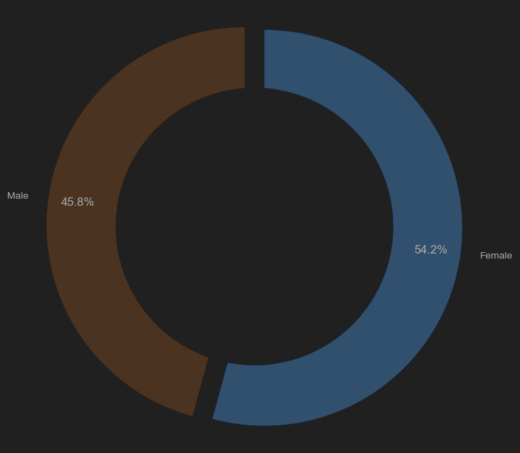

Next, we plotted the count of customers in different age groups using a bar chart. The `plot_age_count` function allowed us to visualise the distribution of customers across different age categories. This plot provided insights into the age composition of the customer base.

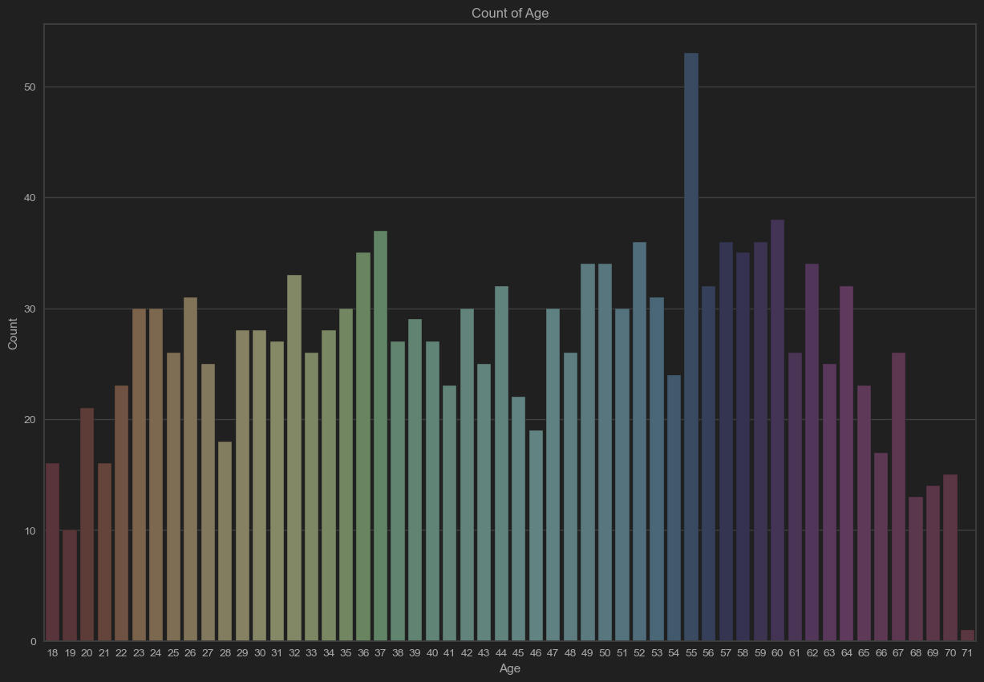

*Data Preprocessing*

We used the `preprocess_data` function to convert categorical columns into binary values, such as “Yes” and “No” responses to menu items. This step ensured compatibility with the clustering algorithms.

*Dimensionality Reduction*

To reduce the dimensionality of the dataset and extract the essential features, we applied Principal Component Analysis (PCA). PCA is a technique that transforms the original variables into a new set of uncorrelated variables called principal components. We used the `perform_pca` function for PCA on the preprocessed data. The function computed the principal components and provided information about the variance explained by each component. This step helped us understand the contribution of each principal component to the overall variance in the data.

*Clustering Analysis*

We employed two popular clustering algorithms for the clustering analysis: K-means clustering and Hierarchical clustering.

**K-means Clustering**

We applied the K-means clustering algorithm to the PCA-transformed data. To determine the optimal number of clusters, we used the KElbowVisualizer, which helps identify the point of diminishing returns in terms of the number of clusters. The visualiser provided a plot of the within-cluster sum of squares (WCSS) as a function of the number of clusters. We selected the number of clusters corresponding to the “elbow” point in the plot. The `apply_kmeans_clustering` function performed the K-means clustering and displayed a scatter plot of the data points coloured by their cluster assignments.

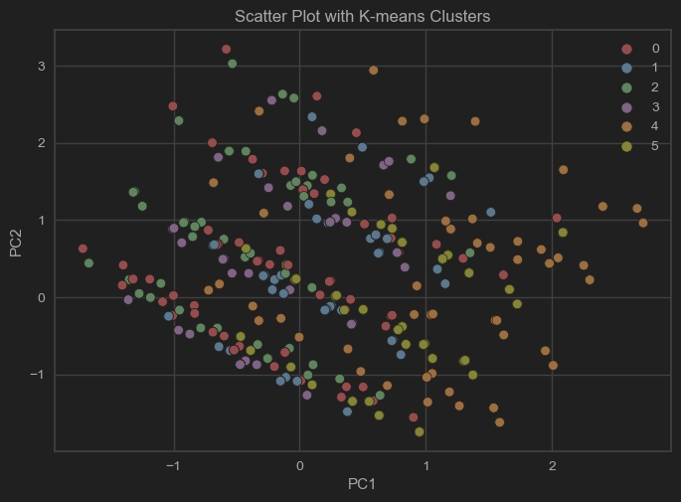

**Hierarchical Clustering**

We also applied Hierarchical clustering to the PCA-transformed data. The `apply_hierarchical_clustering` function performed the clustering and displayed a dendrogram representing the hierarchical structure of the clusters. Additionally, we plotted a scatter plot of the data points coloured by their cluster assignments. We determined the number of clusters by specifying a distance threshold above which we would not merge clusters.

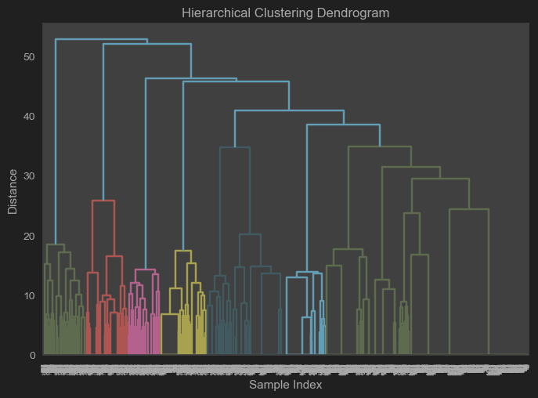

*Cluster Analysis*

After obtaining the clusters, we analysed their distribution and percentages using the `analyze_clusters` function. The function provided a bar chart showing the number of data points in each cluster. Additionally, we computed the percentage of data points in each cluster to assess their relative sizes.

In conclusion, the clustering analysis on the McDonald’s customer dataset revealed distinct groups of customers based on their preferences and characteristics. The K-means clustering algorithm and Hierarchical clustering algorithm identified similar clusters, indicating the robustness of the results. The analysis yielded valuable insights into customer segmentation, which businesses can utilise for targeted marketing campaigns, menu optimisation, and personalised promotions. However, it is important to note that the analysis relies on the available dataset, and further exploration and validation may be necessary to achieve more accurate clustering.

**Step 6: Profiling Segments**

**Identifying Key Characteristics of Market Segments** In the case of data-driven segmentation, the scenario is very different: users of the segmentation solution may have chosen to extract segments based on benefits sought by customers. However, the distinguishing traits of the resulting market categories are unknown until the data has been evaluated. The purpose of profiling is to determine these identifying traits of market segments in relation to the segmentation variables. Profiling entails describing each market segment both on its own and in light of other market segments. When asked about their vacation plans, the majority of winter visitors to Austria say they are going alpine skiing. Alpine skiing might define a market niche, but it might not set that category apart from others.

**Traditional Approaches to Profiling Market Segments** Users (customers, managers) are typically presented with data-driven segmentation solutions in one of two ways: (1) as high-level summaries that oversimplify segment features to the point where they are deceptively simple, or (2) as big tables. that give precise percentages for each segmentation variable for each segment. Such tables are difficult to understand, and it is nearly impossible to quickly summarise the most important findings.

**Segment Profiling with Visualisations** In the data-driven market segmentation process, visualisations are helpful for closely inspecting one or more segments for each segmentation solution. Segment profile understanding is aided by statistical graphics. Additionally, they make it simpler to evaluate the value of a market segmentation strategy. There are a tonne of different solutions that may be found after segmenting data. Making a choice among the potential solutions is crucial. The data analyst and user are helped by visualisations of the solutions in this assignment.

**Assessing Segment Separation** A segment separation plot can be used to display segment separation. The segment separation plot shows the overlap of segments for all pertinent dimensions of the data space.

When there are few segmentation variables, segment separation plots are extremely straightforward; but, as the number of segmentation factors rises, they become more complicated. Segment separation plots, however, give data analysts and users a fast overview of the data condition and the segmentation solution even in these complex settings.

**Identifying Defining Characteristics of Market Segments**

The segment profile plot is a useful visual tool to understand the distinguishing characteristics of different market segments. It displays how each segment differs from the overall sample across various segmentation variables. By clustering the columns of the data matrix, the variables can be reordered to enhance visualisation based on similarity of answer patterns. Marker variables, which are particularly characteristic for a segment, are highlighted in color, while other variables are shown in grey. The plot consists of six panels, each representing one segment, and compares the segment’s values with the overall mean values for each variable.

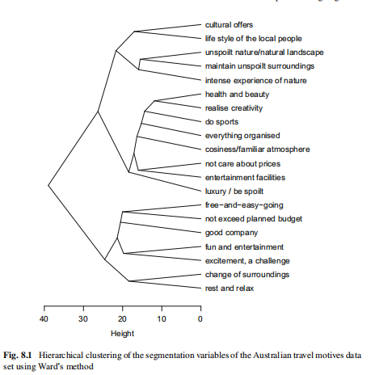

**Step 7 : Describing Segments**

**Developing a Complete Picture of Market Segments :**

Segment profiling and segment description are essential steps in market segmentation analysis. Segmentation variables, chosen during the analysis process, form the basis for extracting market segments from empirical data. Profiling focuses on understanding differences in segmentation variables across segments, while segment description involves additional information about segment members, such as demographics, past behavior, media use, and preferences. Good segment descriptions provide detailed insights into the nature of segments and are crucial for developing a customised marketing mix. Differences in descriptor variables can be studied through descriptive statistics with visualisations or inferential statistics, with visualisations offering a more user-friendly approach compared to traditional tabular presentations. Here are few step to describe it

**1. Visualisation to Describe Market Segments:**

To describe differences in nominal or ordinal descriptor variables across market segments, cross-tabulations are commonly used as the basis for visualisations and statistical tests. The mosaic plot is an effective visualisation method for displaying cross-tabulations, showing the absolute segment sizes through the width of the bars. This approach allows for easy comparison of proportions within each bar and provides a clear representation of the market segments’ sizes.

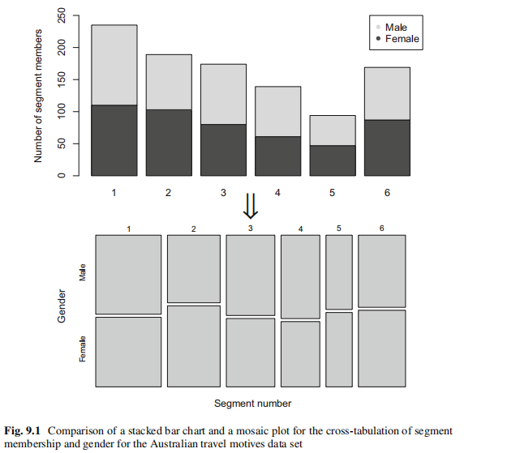

**Predicting Segments from Descriptor Variables:**

To understand market segments and predict segment membership based on descriptor variables, regression models can be employed. Regression analysis involves using independent variables (descriptor variables) to predict a categorical dependent variable (segment membership). These models test differences in all descriptor variables simultaneously and assess the prediction performance in identifying segment membership. By utilising regression techniques, we can determine which descriptor variables are critical in distinguishing and predicting segment membership. The linear regression model, a fundamental approach, assumes a linear relationship between the dependent variable and independent variables, following a normal distribution with mean and variance.

**2.1:Binary Logistic Regression:**

To understand market segments and predict segment membership based on descriptor variables, regression models can be employed. Regression analysis involves using independent variables (descriptor variables) to predict a categorical dependent variable (segment membership). These models test differences in all descriptor variables simultaneously and assess the prediction performance in identifying segment membership. By utilising regression techniques, we can determine which descriptor variables are critical in distinguishing and predicting segment membership. The linear regression model, a fundamental approach, assumes a linear relationship between the dependent variable and independent variables, following a normal distribution with mean and variance.

**2.2 :Multinomial Logistic Regression:**

The given code snippet demonstrates the use of the multinom() function from the N-net package in R to fit a multinomial logistic regression model. The model predicts multiple market segments simultaneously by treating the dependent variable as categorical, assuming a multinomial distribution. The coefficients obtained from the model represent the change in log odds for each independent variable. The summary() function provides additional information such as standard errors. The Anova() function performs a test to determine if dropping any independent variable significantly affects model fit. The predictive performance of the model is assessed by comparing predicted and observed segment memberships using mosaic plots and boxplots of predicted probabilities. The allEffects() function helps visualise the effects of independent variables on predicted probabilities for each segment.

**2.3 Tree-Based Methods:**

Classification and regression trees (CARTs) are a machine learning technique used to predict binary or categorical dependent variables based on independent variables. They offer several advantages, including variable selection, interpretability through visualisations, and the ability to incorporate interaction effects. CARTs are well-suited for analysing datasets with a large number of independent variables. However, a drawback is that the results can be unstable, as small changes in the data can lead to different trees.

The CART approach involves a stepwise procedure where consumers are grouped based on an independent variable, aiming for purity within each group regarding the dependent variable. The resulting tree consists of nodes representing each splitting step, with terminal nodes being the final groups. By moving down the tree, segment membership can be predicted based on the terminal node containing the consumer.

Different tree constructing algorithms exist, varying in the type of splits, selection criteria for independent variables and split points, stopping criteria, and final predictions. Packages like Rpart and partykit in R provide implementations of these algorithms, allowing for tree construction, visualisation, and unbiased variable selection.

**Step 8: Selecting the Target Segment(s)**

**8.1 The Targeting Decision**

The targeting decision in market segmentation involves selecting one or more market segments to focus on for marketing efforts. This decision is crucial as it significantly impacts the future performance of an organisation. Before reaching this stage, a global market segmentation solution is typically chosen, and segments are profiled and described.

In Step 8, the market segments that have passed the knock-out criteria are considered for targeting. These segments should already comply with the criteria set earlier in the process. The next step is to evaluate the attractiveness of the remaining segments and the organisation’s competitiveness in each segment. This evaluation is based on two categories of questions:

**Which market segment(s) does the organisation most desire to target and commit to?**

**Which organisations offering similar products or services are most preferred by each segment? How likely is it that the organisation will be chosen and that the segment will commit to the organisation?**

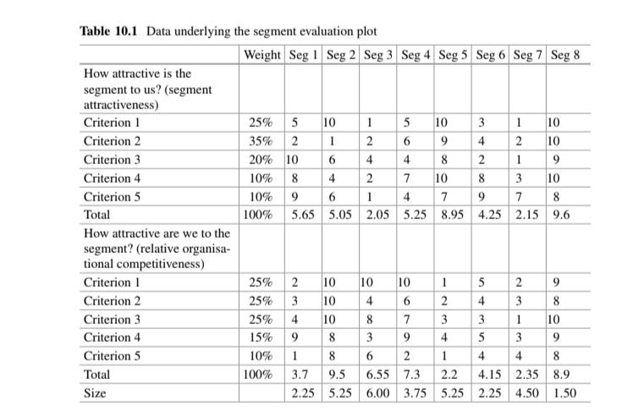

To visualise the relative attractiveness of each segment and the organisation’s competitiveness, a decision matrix is commonly used. Different variations of the decision matrix exist, such as the Boston matrix, General Electric/McKinsey matrix, directional policy matrix, or market attractiveness-business strength matrix. The matrix helps evaluate alternative market segments and facilitates the selection of one or a few target segments.

The decision matrix typically plots segment attractiveness on the x-axis and relative organisational competitiveness on the y-axis. Each segment is represented as a circle, with the size of the circle reflecting additional criteria like contribution to turnover or loyalty. The segmentation team determines which variation of the decision matrix best suits their decision-making process.

To populate the decision matrix, the team relies on the information gathered during segment profiling and description. Each segment’s attractiveness value for each criterion is assigned based on the profiles and descriptions resulting from the previous steps. The values are weighted according to the criteria’s importance and then added up to determine a segment’s overall attractiveness. The same process is followed for evaluating the organisation’s competitiveness in each segment.

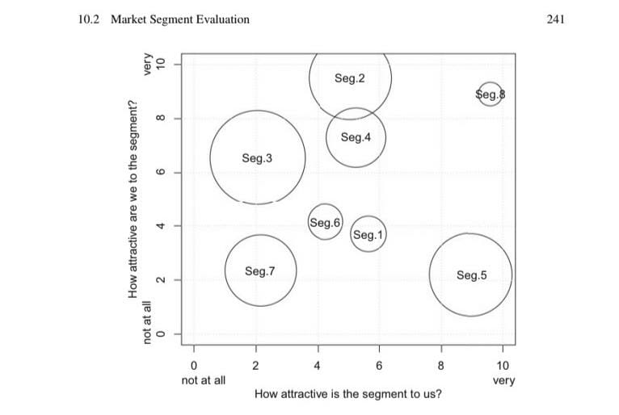

The resulting segment evaluation plot, based on the decision matrix, provides a visual representation of each segment’s attractiveness to the organisation and the organisation’s competitiveness in each segment. Bubble size on the plot can represent additional factors such as profit potential or other relevant criteria.

The plot serves as a basis for discussions within the segmentation team. It helps identify segments that are highly attractive to the organisation and have high profit potential, as well as segments where the organisation’s offer is well-received. Based on the plot, the team can make informed decisions about which segment(s) to target.

In R, the “MSA” package provides functions to create the segment evaluation plot using the decision matrix data. The “decision Matrix” function takes the matrices and weights as inputs and allows customisation, such as specifying the bubble size based on a relevant criterion like profitability.

**Step 9: Customising the Marketing Mix**

**Implications for Marketing Mix Decisions**

Marketing involves using a mix of ingredients, known as the marketing mix, to achieve sales results. The traditional marketing mix consists of the 4Ps: Product, Price, Promotion, and Place. Market segmentation is an essential part of strategic marketing, along with positioning and competition. The segmentation-targeting-positioning (STP) approach suggests a sequential process: segmentation, targeting, and positioning. Customising the marketing mix to the target segment is crucial for maximising the benefits of market segmentation. This may involve designing new products, modifying existing ones, adjusting prices, selecting distribution channels, and developing communication and promotion strategies that appeal to the target segment. The choice of segmentation variables depends on the specific marketing objective, whether it’s pricing, advertising, or distribution decisions. However, market segmentation analysis is typically guided by the insights gained from the detailed description of the target segment, rather than being focused solely on one of the 4Ps.

**Product**

This demonstrates how the selection of a target segment influences the development of the marketing mix, which consists of the traditional 4Ps: Product, Price, Place, and Promotion. Customising the marketing mix to the target segment is crucial for maximising the benefits of market segmentation. The selection of a target segment may require designing new products, modifying existing ones, adjusting prices, selecting appropriate distribution channels, and developing communication and promotion strategies that appeal to the target segment. Market segmentation analysis can be centred around one of the 4Ps, such as pricing, advertising, or distribution decisions, depending on the specific goals. However, the insights gained from the detailed description of the target segment guide the organisation in developing or adjusting the marketing mix to effectively cater to the chosen target segment.

**Price**

When developing the product dimension of the marketing mix, an organisation must consider customer needs and may modify existing products rather than creating entirely new ones. Product-related decisions also include naming the product, packaging, warranty offerings, and after-sales support services. The market segments identified in the Australian vacation activities dataset provide an example of how target segment selection drives product design or modification. For instance, if targeting segment 3 characterised by a strong interest in visiting museums, monuments, and gardens, a possible product measure could be developing a “MUSEUMS, MONUMENTS & MUCH, MUCH MORE” product accompanied by an activities pass, facilitating the discovery of relevant activities during the vacation planning process. Additionally, highlighting the destination’s gardens as a unique attraction could be an opportunity to target this segment effectively.

**Step-10: Evaluation and Monitoring**

**10.1. Ongoing Tasks in Market Segmentation**

Market segmentation analysis does not end with the selection of the target segment, and the development of a customised marketing mix rather it must be viewed as an ongoing strategic decision process.

After the segmentation strategy is implemented, two additional tasks need to be performed on an ongoing basis:

1. **Effectiveness of the segmentation strategy needs to be evaluated** : Much effort goes into conducting the market segmentation analysis, and customising the marketing mix to best satisfy the target segment’s needs. These efforts should result in an increase in profit else market segmentation strategy is considered failed.
2. **Market isn’t Static** : As Consumers change, the environment, and actions of competitors change, process of ongoing monitoring of the market segmentation strategy must be devised which ranges from regular review by the segmentation team, to a highly automatised data mining system.

**10.2. Evaluating the Success of the Segmentation Strategy**

The aim of evaluating the effectiveness of the market segmentation strategy is to determine whether developing a customised marketing mix for one or more segments did achieve the expected benefits for the organisation. For regular organisations it is profit and for non-profit organisations it may be number of recruiters volunteers.

These measures can be monitored continuously to allow ongoing assessment of the segmentation strategy. In addition, taking a longer term perspective, the effectiveness of targeted positioning could be measured.

**10.3. Stability of Segment Membership and Segment Hopping**

Number of studies have investigated change of market segment membership of respondents over time i.e. segment landscape changes over time.

Changes in segment membership are problematic if:

1. Segment sizes change (Especially if the target segment shrinks)

2. Nature of segments changes in terms of either segmentation or descriptor variables.

Changes in segment size may require a fundamental rethinking of the segmentation strategy whereas Changes in segment characteristics could be addressed through a modification of the marketing mix.

In some product categories, segment members change segments regularly, they “**Segment hop**” which doesn’t occur erroneously can happen due to various factors.

Segment hopping consumers have been referred to as Centaurs or Hybrid consumers for example based on different tourist places & the expenditures they spend customers give appropriate response options as feedback. These tourists segment hop.

There are different models to study about Segment hopping. Some of them are:

1. Ha et al. model segment hopping using Markov chains. They use self-organising maps (SOMs) to extract segments from a customer relationship management database; and Markov chains to model changes in segment membership over time.
2. Lingras et al. investigate segment hopping using a modified self-organising maps (SOMs) algorithm. They study segment hopping among supermarket customers over a period of 24 weeks; consumers are assigned to segments for every four week period and their switching behaviour is modelled.

Accepting that segment hopping occurs has implications for market segmentation analysis, and the translation of findings from market segmentation analysis into marketing action.

Most critically, we cannot assume that consumers are well behaved and stay in the segments. Optimally, we could estimate how many segment members are hoppers. Those may need to be excluded or targeted in a very specific way.

**10.4. Segment Evolution**

Market Segments evolve over time and the environments in which the organisation operates, and actions taken by competitors change.

Haley (1985), the father of benefit segmentation, says that not following-up a segmentation study means sacrificing a substantial part of the value it is able to generate and to recommend a tracking system called “Early warning system” to ensure that any changes are identified as early as possible and acted upon.

Number of reasons drive genuine change of market segments, including: evolution of consumers in terms of their product savviness or their family life cycle; the availability of new products in the category; and the emergence of disruptive innovations changing a market in its entirety.

Due to the general lack of natural segments in empirical consumer data, most segmentation solutions and segments are unstable, even if segment extraction is repeated a few seconds later with data from the same population and the same extraction algorithm.

It is critical to conduct stability analysis at both the global level and the segment level to determine the baseline stability. Only if this information is available, can instability over time be correctly interpreted.

The MONIC framework developed by Spiliopoulou et al. allows the following segment evolution over time: segments can remain unchanged, segments can be merged, existing segments can be split up, segments can disappear, and completely new segments can emerge.

This method uses a series of segmentation solutions over time, and compares those next to each other in time. For the procedure to work automatically, repeated measurements for at least a subset of the segment members have to be available for neighbouring points in time; the data needs to be truly longitudinal.

In Olivier & Gama Framework, framework, the following taxonomy is used for changes in segments over time:

1. Birth: a new segment emerges.
2. Death: an existing segment disappears.
3. Split: one segment is split up.
4. Merge: segments are merged.
5. Survival: a segment remains almost unchanged.

The procedure can only be automated if the same consumers are repeatedly segmented over time; data must be truly longitudinal.

In conclusion, it is very risky not to be up to date in market evolution ignoring dynamics in market segments and keep updating according to market & consumer needs.

**10. Conclusion:**

In conclusion, this market segmentation study has provided valuable insights into understanding our target market and has paved the way for effective marketing strategies. Through the thorough analysis of data and the identification of distinct segments, I have gained a deeper understanding of our customers and their preferences.

The key findings of this market segmentation study include the following:

*Identification of Target Segments:*

By analysing the data, we have identified several distinct segments within our target market. These segments exhibit unique characteristics, behaviours, and preferences, enabling us to tailor our marketing efforts to their needs.

*Understanding Customer Needs:*

Through the segmentation process, we have comprehensively understood our customers’ needs, desires, and pain points. This understanding allows for developing targeted marketing messages and delivering personalised experiences that resonate with each segment.

*Improved Marketing Effectiveness:*

By segmenting the market, we can allocate resources more effectively and focus marketing efforts on the segments offering the most remarkable growth and profitability potential. This targeted approach maximises the impact of marketing campaigns and generates better returns on investment.

*Enhanced Customer Engagement and Satisfaction:*

The segmentation findings enable the development of tailored products, services, and marketing strategies that meet the specific requirements of each segment. Enhancing customer satisfaction by addressing their unique needs and preferences fosters stronger relationships and builds customer loyalty.

*Competitive Advantage:*

We gain a competitive advantage through market segmentation by understanding the distinct segments within our market and customising offerings to match their preferences, which allows differentiation from competitors and positions us as the preferred choice for our target customers.

The insights gained from this market segmentation study will guide our marketing strategies and decision-making. We will leverage the identified segments to develop targeted campaigns, refine our product offerings, and enhance customer experiences. Additionally, continuous monitoring and evaluation of market dynamics will be crucial to adapt the segmentation strategy as the market evolves.

In conclusion, market segmentation is a powerful tool to understand our customers better and tailor our marketing strategies to meet their needs. By focusing on these segments, we can create meaningful connections, drive business growth, and achieve sustainable success in our target market.

**GitHub Links**

1. [Abdul Jaweed](https://www.linkedin.com/in/abdul-jaweed-datascientist/):

<https://github.com/Abdul-Jaweed/Feynn-Lab-Internship>

1. [Ashvath Suresh Babu Piriya](https://www.linkedin.com/in/ashvath-suresh/):

<https://github.com/A2162014/Feynn-Labs-Project-2.git>

1. Shaleen Mishra:

https://github.com/srvapm/Fynnlab_project2.git

1. Yashaswini M:

<https://github.com/Yashaswini29026/mac_donalds_casestudy>